Standard Operating Procedure

|  |  |  |  |
| --- | --- | --- | --- |
| Document Name: |  | Version: | 1.0 |
| **Authorized by:** |  | **Date:** |  |

**Revision History**

|  |  |  |  |
| --- | --- | --- | --- |
| **Rev #** | **Release Date** | **Updated by** | **Reason for Update** |
| 1 |  | Ananth |  |
|  |  |  |  |
|  |  |  |  |
|  |  |  |  |

* Policy numbers provided in the spreadsheet will often have the preceding 0 dropped – this must be re-added in order to be identified within RS.
* When adding an RID to a Policy, the Group name will have a proceeding **P** in the drop-down
* When adding an RID to a TFN, the Group name will have a proceeding **T** in the drop-down

Where a HAS is to be added instead of RID, it is located in the drop-down as **HSACallsToHSAxxx\*\*\*\*\*** (Again, depending on whether this is being added for a Policy or TFN will determine whether a P or T proceeds the HAS string).

Creating a new Policy

1. Default drop-down > **Uniprise**
2. AcctMgePhoneNumber drop-down > **Policy ID**
3. **Create as Data Element**

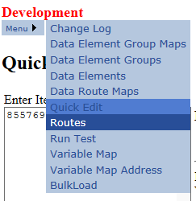

Select Routes it redirects to the Routes page.

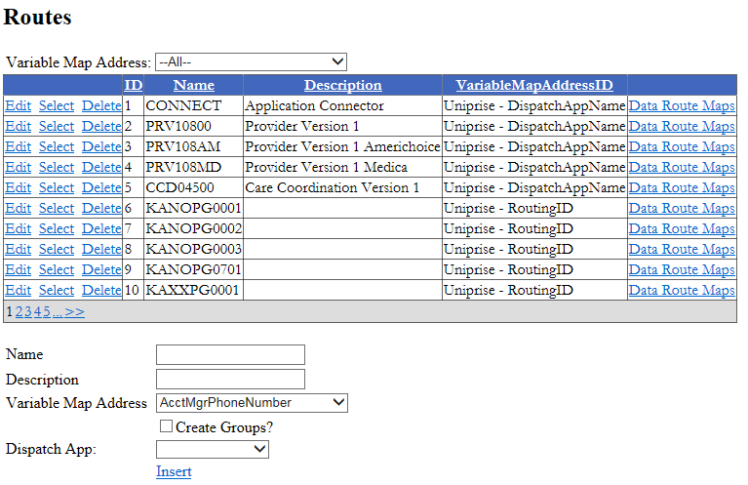

When the new RID to be added does not exist

1. **Menu > Routes**
2. Name & Description (**name of new group**)
3. Variable Map Address: **RoutingID**
4. Check **Create Groups?** checkbox
5. Dispatch App: **VETSSCE1**
6. Insert

Creating a new Policy

1. Default drop-down > **Uniprise**
2. AcctMgePhoneNumber drop-down > **Policy ID**
3. **Create as Data Element**

Creating a new TFN

1. Updates are only required for existing TFNs. Therefore if the provided TFN cannot be identified, it has not been provided correctly by the business.